**DOCUMENTATION DESCRIBING FIRST PHASE OF THE PROJECT – NUTRIBOT**

Our project NutriBot, consists of features that provide the user suggestions and ideas to have a healthy lifestyle. Some of the features of our application include:

* Calculating the BMI (Body Mass Index) of the user.
* Keeping a track of the user diet on daily basis.
* Suggesting the exercise to burn out extra calorie intake.
* Suggesting different health recipe for healthy diet.
* Helping the user to search nearby stores for the food product.

In the first phase, we have implemented two features of our project:

* Calculating the BMI (Body Mass Index) of the user.
* Suggesting different health recipe for healthy diet.
* **Calculating the BMI (Body Mass Index) of the user:**

This will calculate the Body Mass Index of the user depending upon the age and the weight of the user. User can enter the height (in feet or inches) and his weight (in Kilograms or lb). The application will then calculate the BMI depending upon these two factors. We have created a java file “DietCalc.java”, which is taking the user input and is responsible for this feature.

* **Suggesting different health recipe for healthy diet:**

This module will give different ways of cooking the vegetables, making salad. It suggests how to make the food and increase the nutrition content with least calorie. It gives the user a diet plan to be followed so that the user can make different choices and continue with the one he/she likes. For now, we are using static data which provides the information of the recipe till the time have our database. The images used in this module is being store at :NutriBot-master\app\src\main\res\drawable

**FIRST ACTIVITY (STILL WORKING ON IT)**

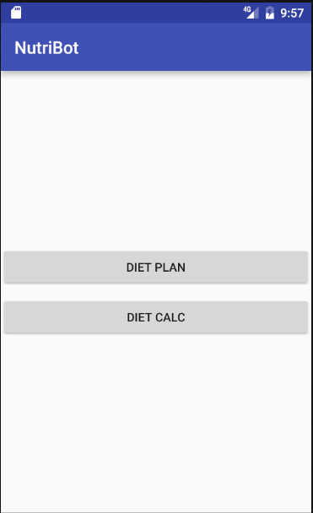

* When the user clicks on **DIET PLAN:**

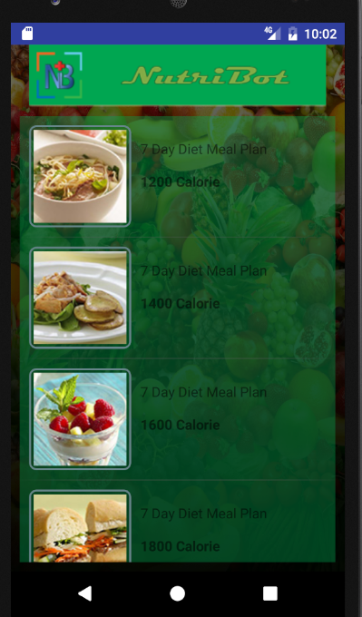

This module suggests the user with different options on how much calorie can be lost if he follow different eating habits. He can select any of these and go to the next activity. Here the user selected 1400 calorie option.

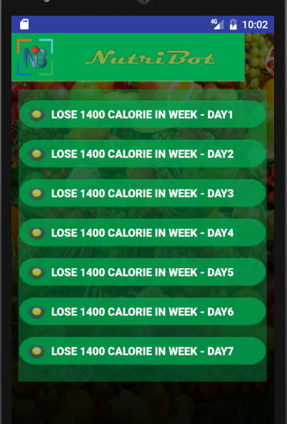

The user can check the Diet plan for 7 days and follow the recipe which he likes to have a healthy lifestyle. This shows him/her one day schedule for breakfast, snack, lunch, supper, dinner. User here selected Day2

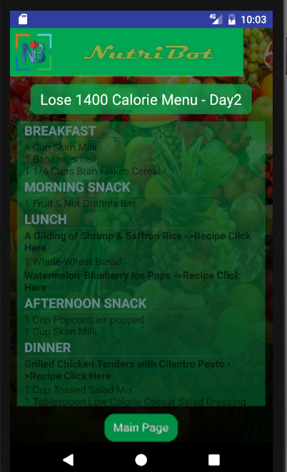

When the user selects the meal,he gets the receipe for that dishes.

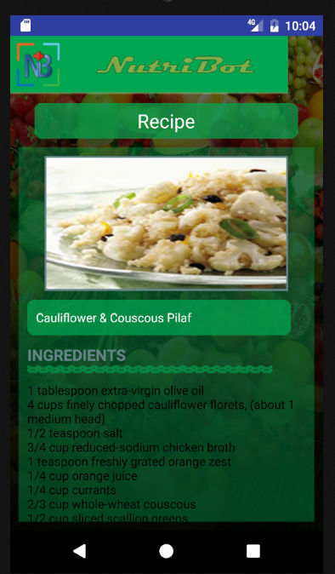

* When the user clicks on **DIETCALC:**

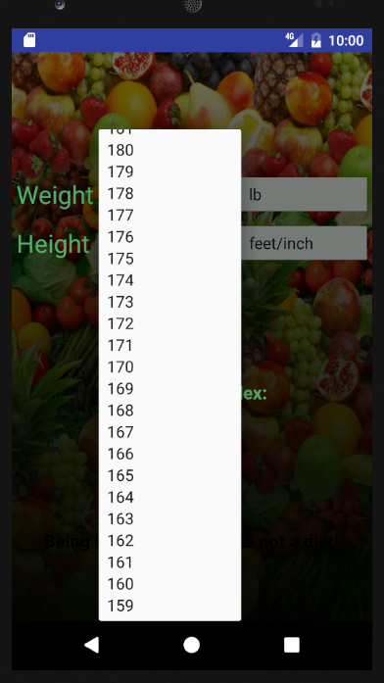

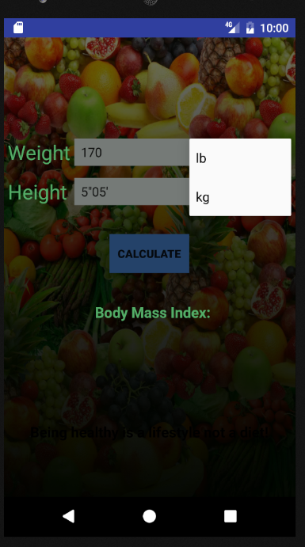

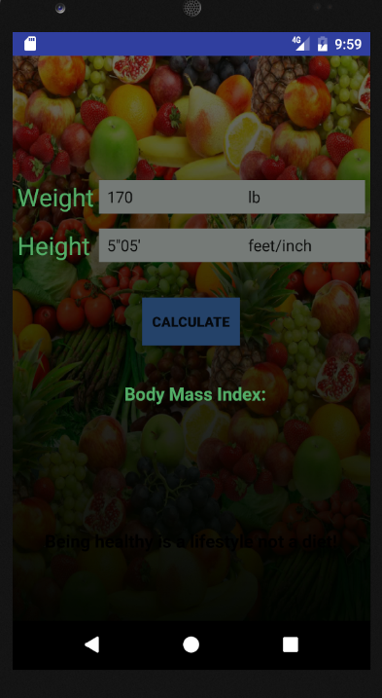

The user here, enters or either select from drop down the weight and his height.

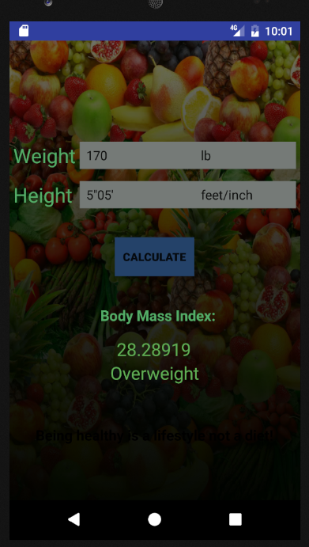

User gets the result if he is over weigh t,under weight or normal BMI.